Switch statements
Workshop #5
Flutter Developer Bootcamp

Purpose
This workshop demonstrates the use of the switch statement in Dart, a programming language used for Flutter development. The switch statement is used to execute different blocks of code based on the value of a variable. Here, the variable grade is used to determine which message to print.

Problem
In the given workshop demonstrates the use of a switch statement to handle different possible values of a variable grade and print corresponding messages.This Dart program evaluates a student's grade and prints a corresponding message. It stores the grade in a variable named grade and uses a switch statement to check its value. The switch statement compares grade against different cases: 'A', 'B', 'D', and 'F'. If there's a match (e.g., grade is 'A'), the corresponding message ("Excellent!") is printed. Each case has a break statement to prevent the program from accidentally checking subsequent cases. Finally, a default clause handles any invalid grades (values other than 'A', 'B', 'D', or 'F') by printing "Invalid grade".You need to create grade ‘C’ and print the message (“Fair”).

How to Solve
- Checkout the workshop from Git Repo:
git clone -b <user-branch> <repo-URL>
- Open the root folder inside VS Code
- Open the root folder in terminal
- Run the command dart run filename.dart
- Create a new case 'C' was added to handle the grade 'C' and print the message "Fair".
- The switch statement was extended to include the new grade case.
- Each case still ends with a break statement to ensure only the matching case is executed.
- The default case remains to handle any invalid grades.
- Go To File: <specific-file--method> à <method-name>, implement your logic.

You will Achieve
When you complete this workshop you will learn the following:

Methods and Functions
- main() Function:
- Entry point of the Dart application.
- print() Function:
- Outputs text to the console.

Control Flow with Switch Statement
- Switch Expression:
- switch (grade)
- Case Labels:
- case 'A':
- case 'B':
- case 'D':
- case 'F':
- Default Case:
- default:
- Break Statements:
- break;

Screenshots

Before implementation (without Grade C)

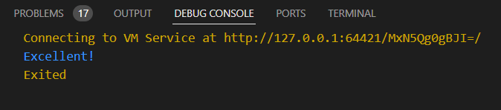

After implementation (with Grade C)

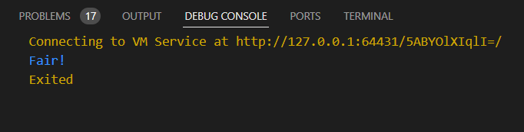

How to submit your workshop
Push your project back to the same git branch using command:
<command name>

Happy Coding!

